Present: Adrian Pang, Janelle Julian, Jesse Gou, Erica Binder, Anican Yu
Late:
Regrets:

 |  | Motions / Action
1. | Call to Order
 | Adrian called the meeting to order at 3:12pm
2. | agenda | Moved/Seconded:
 | Adrian announced the agenda / Anican seconded adoption of the agenda | Janelle moved to adopt the agenda and previous minutes/ Jesse seconded adoption of the agenda and previous minutes
3. | check-ins and updates | Action Item:
 | - Fridge – has been moved and re-installed  - Lockers – all have been completed, locks just need to be cut ; Janelle and Jesse will do this tonight  - Anican – has checked in with Mikayla from the dance team, there is a good chance we will get her as a teacher for free but this will be worked on in the coming weeks  - Adrian – has not furthered progress for Little Night Music, is pushing advertising for wellness week this week and next week  - Erica – presented summary of breakfast for MUSA for wellness week, we’ve narrowed down to one day and pastries, budget TBD  - Mark – we have to update AMS clubhouse to book a room  - Adrian – will contact previous president of MUSA for more information and Chris Hakim  - Jesse – we have to determine a room before we determine security  - Erica, Anican and Jesse – have to take one online class to get alcohol serving license | - Janelle -ensure all locks are cut  - Erica - contact Loretta Knopp, Liam Robertson, Breka, and stay in contact with Chris Hakim and present a FINAL BREAKFAST SOLUTION next meeting (breakfast day is 29th)  - Anican – solidify dance team planning for formal  - Adrian – contact Chris Hakim and Michelle regarding AMD Clubhouse
4. | agm | Action Item:
 | - Will take place on the 29th as planned | - Mark – create a budget presentation
5. | ELECTIONS | Action Item:
 | - Deferred until next week; awaiting elections coordinators information | DEFERRED
6. | MERCHANDISE CONTEST | Action Item:
 | - We will sell merchandise closer to Christmas time, awaiting information from Dad’s printing
7. | wellness week | Action Item:
 | - 29th – breakfast and coffee starting at 8:30  - 31st – dress-up day with free coffee (Halloween initiative as well), culminating prize is Creed tickets and candy prizes  - Creed raffle is entered by placing a ‘note’ and positive message  - Nice memes on each locker; put in dropbox and get approved by at least 2 people on MUSA exec before printing and posting  - Advertise events for other faculty  - Pie a Prof? | - Adrian – will get chamomile tea  - Mark will get coffee Monday morning  - Erica will get Breka stuff Monday morning (pastry and bagels)  - Curate memes in shared dropbox folder
8. | formal | Action Item:
- Dance theme TBD by dance team teacher
- Refer to (3) Check-Ins and Updates
9. | little night music | Action Item:
 | - November 9th- exec members should volunteer if possible | - Anican will advertise to AMS  - All – advertise to music faculty via word of mouth and large ensemble announcements
Adjourned

this meeting is adjourned at 3:46pm

Respectfully submitted by Erica Binder

Approved by:

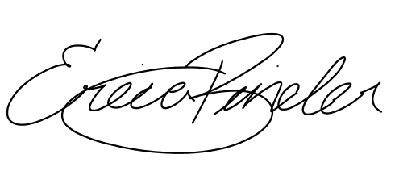

_____________________________ ______________________________
Adrian Pang, President Erica Binder, VP Administration

