Present: Adrian Pang, Mark Petrov, Erica Binder, Jesse Guo, Janelle Julian (interim),
Late:
Regrets: Anican Yu

 |  | Motions / Action
1. | Call to Order
 | Adrian called the meeting to order at 4:28 pm.
2. | agenda | Moved/Seconded:
 | Adrian announced amended agenda, Erica motioned to accept agenda | Mark moved to adopt the amended agenda/ Jesse seconded adoption of the amended agenda  Janelle moves to adopt previous minutes / Jesse moves to accept previous minutes
3 | check-ins & updates | Action Item:
 | - Anican (proxy Adrian) – AMS events will be advertised through MUSA social media; climate art competition and SASC  - Jesse – Scavenger hunt prizes; have not been bought yet  - Beginning of year BBQ cleanup was done incorrectly as a result of lack of MUSA exec participation  - This emphasizes the need for a schedule for next year | - Jesse – transfer the task of buying giftcards from Anican to Jesse
4. | end of year bbq |  | Action Item:
 | - Erica proposed an event at Koerner’s as an end-of-year faculty event; we will postpone planning of this event until next semester |  | - Erica – will investigate costs and timeline late this semester
5. | fridge | Action Item:
 | - Fridge policies need to be created and placed on fridge  - Fridge policies are as follows; | - Fridge has to be moved from MUSA office to 3rd floor  - Adrian – will purchase a microwave food cover (not on a specific timeline)  - Task of removing food from fridge every Sunday will be delegated to the fourth floor manager
6. | elections (ammended from agenda “by-elections”) | Action Item:
 | - Nomination forms have been created  - We need one (1) month minimum from this point to the voting to have an online platform  - AGM will be on October 29th; 12, 1, or 2 pm start time  - At the AGM we will present our budget summary | All – spread the word for elections  - Adrian – will book a room for AGM (October 29th)  - All – collaborate on a committee member application form
7. | merchandise contest | Action Item:
 | - We still only have one submission; is void  - Will remain open with an indefinite end date | All – advertise to your friends
8. | wellness week | Action Item:
 | - Last year included several events  - Tentatively October 29-November 3  - Next week Adrian will update us on cross-club collaboration  - November 9 – 4th floor library space will be decorated and used for the UBC chamber club as a sight-reading session/social | All – brainstorm ideas over the next week; reconvene next meeting and also send to Adrian  - Mark- will secure coffee for the winter coffeehouse  - Jesse will provide MUSA decorations day of
9. | formal | Action Item:
 | - Possible themes; Mardi Gras, Folk, Eastern European, Vintage Hollywood, Paris, Latin | Review and decide of you like one
10. | evangelos | Action Item:
 | - Headshots and group photos have been received, we need to pick a group photo
11. | next meeting | Action Item:
ADJOURNMENT
Meeting adjourned at 5:40pm

Respectfully submitted by Erica Binder

Approved by:

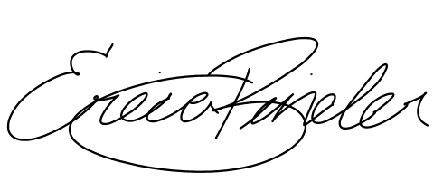

_____________________________ ______________________________
Adrian Pang, President Erica Binder, VP Administration

