Present: Anican Yu, Erica Binder, Justine Lin, Mark Petrov, Albert Wu, Janelle Julian
Late: Jesse Guo
Regrets:

 |  | Motions / Action
1. | Call to Order
 | Erica called the meeting to order at 3:05pm
2. | agenda | Moved/Seconded:
 | Erica announced the agenda | Janelle moved to adopt previous minutes/ Justine seconded adoption of previous minutes  Anican moved to adopt agenda/ Erica seconded adoption of the agenda
3. | check-ins and updates | Action Item:
 | -Mark has submitted room request, but it has not been confirmed (should know by next Tuesday).  -Feb 9th, March 2nd, 9th potential dates  - Dance instruction almost confirmed, will likely be free  -AMS fall break email blast  -Fall reading break, extended winter holiday  -Survey incoming.  -Affects exam scheduling  -MUSA asked to advertise the survey to boost student participation – we will advertise via social media  -Art Auction Facebook group can be created whenever convenient  -Voice and 3rd year representative form ready.  -Lasserre Fridge request- Lasserre students have not replied to grant offer | -Anican and Janelle - plan AMS fall break survey facebook/insta post  -Mark - write a description for Fourth Floor Lounge Representative  - Janelle – send Erica art pictures for cataloging  - Erica – compile all descriptions into a document on the dropbox
4. | BY-ELECTION AND APPOINTMENTS | Action Item:
 | Aydan Con has submitted our ballot and is waiting on AMS approval | -Elective Committee talk to Ayden about his process, and start advertising this week (next Tuesday)  -Aim to get in contact with Ayden before Monday.  -Aim to begin week-long advertising period Tuesday  -Erica – create posters and post on Dropbox for distribution  -Erica and Janelle - get Facebook and Instagram posts ready for Tuesday  -Erica – add signature sheet to dropbox  -Jesse - create google form for positions other than Interim President (refer to interim president format)  -Election committee – ensure signature forms are available from music office (and hard copies of application form?)
5. | FORMAL | Action Item:
 | -Brayden’s dad (member of the music faculty) has a catering company and would be a good candidate for catering the dance  - This is a more efficient and affordable option than Tacomio  - Depending on our date, we have 4-8 weeks to advertise the formal  ROUGH TIMELINE  Week 1 ( 1/11- 1/18)  -Print out Latin America iconography  -No flags  -Carnival pictures  -Mexico, Brazil  -Did you know facts  -Tacos  Week 2 (1/18- 1/25)  -Date Confirmed  -Facebook event  -Food teaser  Week 3 (1/25- 2/1)  -Dancing and decoration teaser  Week 4 (1/25- 2/9)  -Formal Week | - Anican – Get into contact with Brayden’s dad and inquire about catering deal/ what information is required from MUSA by next meeting  -Jesse – assemble images for *mission guerilla marketing* and add document to dropbox  -All – begin *mission guerilla marketing*  - Mark – confirm room booking ASAP and price of room
6. | BRASSFEST | Action Item:
 | -MUSA will provide refreshments  - Pickup/ table shifts to be arranged in a following meeting  -Brassfest will feature an art auction | -Erica - make a “when to meet”
7. | VALENTINE’S DAY EVENT | Action Item:
 | -Valentine event tabled for next week | Erica – add Valentine’s Day Event to agenda for next week
8. | THIRD FLOOR WATER COOLER | Action Item:
 | - Pending reply
Adjourned
Meeting adjourned at 3:58 pm

Respectfully submitted by Albert Wu, First Year Representative

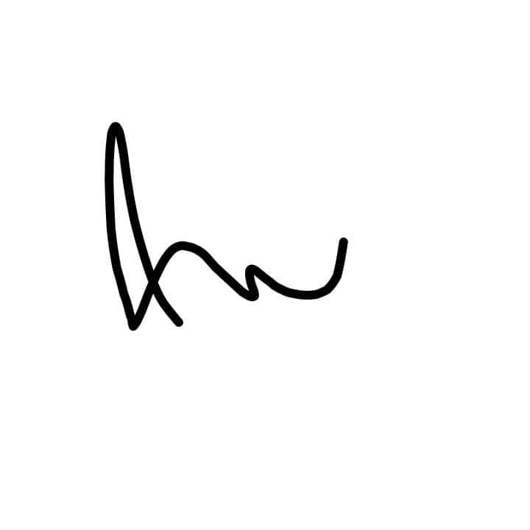
Approved by:

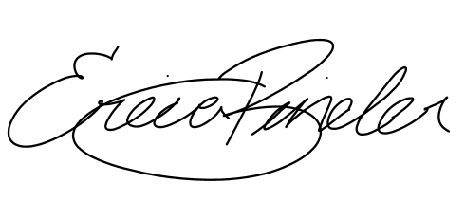

_____________________________ ______________________________
Erica Binder, Acting President Albert Wu, First Year Representative

